**PROFILE**

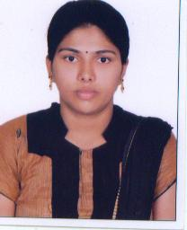

**Personal Data**

Name: D.Babitha

Father’s name: P. Surya Nagendhra rao

Date of birth: 16-08-1987

Designation: Lecturer in Statistics

Employee ID:

Mobile No: 9059473039

E-mail: babithadangeti@gmail.com

**Current position**

Lecturer in Statistics

Y.V.N.R. Government Degree College,

Kaikaluru, Eluru (D.t). A.P -521333

**EDUCATIONAL QUALIFICATION**

|  |  |  |  |  |  |
| --- | --- | --- | --- | --- | --- |
| **Sno** | **Degree** | **Institution** | **Year of pass** | **Specialization** | **Grade** |
| **1** | M.Sc | Osmania University | 2012 | Statistics | 58% |
| **2** | B.Sc | St’ Ann’s Degree College For Women Hyderabad | 2009 | Mathematics, Statistics, Computer Science | 77% |

**PROFESSIONAL EXPERIENCE**

|  |  |  |  |
| --- | --- | --- | --- |
| **Sno** | **Designation** | **Institution** | **Year** |
| 1 | Lecturer in Statistics | David Memorial Degree college: Tarnaka | 2016-2017 |
| 2 | Lecturer in Statistics | Haindavi Degree College: ECIL | 2017-2018 |
| 3 | Lecturer in Statistics | SRR & CVR Government degree college: Vijayawada. | 2018-2021 |
| 4 | Lecturer in Statistics | Y.V.N.R Govt Degree College: Kaikaluru | 2021-till date |

**Faculty Development & Academic Extensive Programmes**

3 Day Training Programme on Internship and LMS at nodal resource centre, SRR andCVR GDC, Vijayawada from 23-01-2023to 25-012023 by CCE, AP.